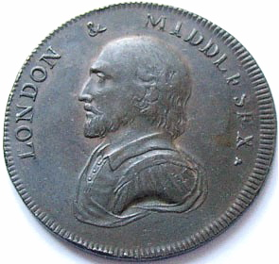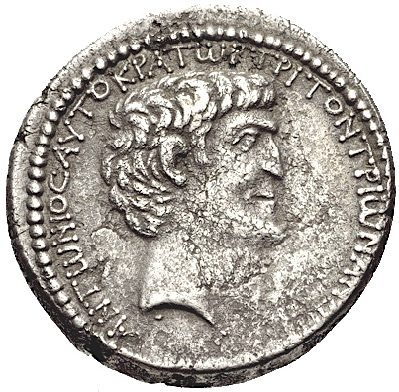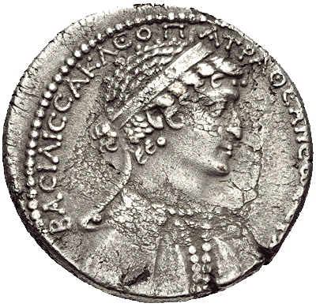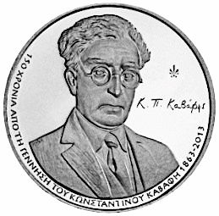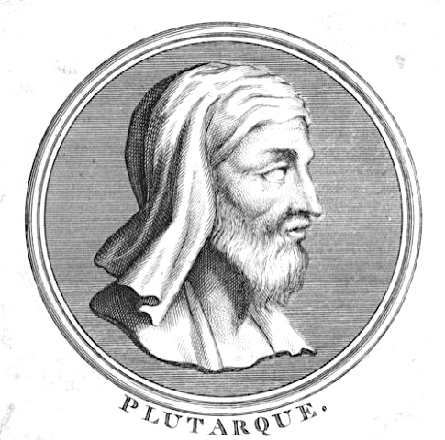

**ΜΟΝDAY**

**27th FEBRUARY 2017**

**17:30**

**Room B4, Classics Department**

**King’s College London**

**Anthony Hirst**

***ANTONY AND CLEOPATRA***

**AND CAVAFY**